

**Assignment -2**

**Statement of Work**

**CSE 307: System Analysis and Design**

**Section: 03 (Spring 2024)**

**Submitted By:**

Sumaiya Jannat (ID: 1730469)

Kaushik Dey Joy (ID: 1821818)

Shamsad Sanzid Ahmed (ID: 1822089)

Jahid Hasan Milon (ID: 1930666)

Abir Hossain Sangram (ID: 2022734)

**Submitted To:**

**Sabrina Alam**

Lecturer,

School of Engineering, Technology and Sciences,

Independent University, Bangladesh (IUB)

**Date:** 13th March, 2024

# Information Gathering Methods

Information must be gathered, distributed, and integrated into project management activities and processes in order to be managed. Repeated procedures are used to produce and arrange data from a variety of sources using information gathering methods. In this project we have used three relevant information gathering methods such as **Interviewing**, **questionnaires** and **JAD (Joint Application Design)**.

## Interviewing

Interviews are one-on-one or small-group talks with stakeholders to learn about their needs, requirements, and expectations. Interviews, which can be organized or unstructured depending on the demands of the system, are frequently used to acquire comprehensive information from subject matter experts or end-users.

Tour Makers software offers an easy-to-use interface, intuitive navigation, and robust features, making it an ideal solution for both tour operators and tourists. Its interactive map, live-chat feature, multilingual support, and seamless booking system ensure a delightful experience for all stakeholders involved in the tourism industry.

### Interview questions for Users :

* + 1. What type of tours do you offer or plan to offer in Bangladesh? (e.g., historical, cultural, adventure, wildlife, etc.) (Open-ended)
    2. How do you currently handle tour bookings and reservations? What improvements would you like to see in this process? (Open-ended)
    3. What information do you consider essential to include in your tour destinations? Are there any specific requirements or cultural considerations you need to address? (Open- ended)
    4. What features would you like to see in the tour makers software to enhance the overall tour experience and streamline your operations? (Open-ended)
    5. How do you handle emergencies or unexpected situations that may arise during tours? (Open-ended)

### Interview questions for Tour Makers/Guides:

1. How do you gather feedback from tourists about their experiences? Do you have a system for reviews and testimonials? (Closed-ended)
2. What are the primary challenges you face in managing tours and tourists in Bangladesh? (Open-ended)
3. How did you handle the issues? (Open-ended)
4. Can you tell us about your previous experience as a tour arranger? What kind of tours have you led, and how do you handle different types of groups or tourists?
5. Tour arranging often involves dealing with diverse groups of people. How do you adapt your communication style to cater to different audiences, such as families, international travelers, or senior citizens?

### Interview questions for Hotel Managers:

1. Can you please provide an overview of your hotel and the types of tours or activities you offer to guests? (Closed-ended)
2. How do you currently manage tour bookings and scheduling at your hotel? (Open- ended)
3. How do you communicate with tour makers/guides and guests? (Open-ended)
4. What role does technology play in your tour management operations, and how do you envision the integration of a tour makers software? (Open-ended)
5. How do you collect and analyze feedback from guests regarding the tours they participate in? (Open-ended)

### Interview questions for Transport Services:

1. Can you tell us about your transport service and the types of tours you typically support in Bangladesh? (Open-ended)
2. How do you currently manage vehicle reservations and allocations for tour groups? (Close-ended)
3. What challenges do you face in coordinating transportation logistics for tours? (Open- ended)
4. Do you need the software to handle multiple types of vehicles (e.g., buses, vans, cars) and their respective capacities? (Open-ended)
5. How do you track vehicle maintenance and ensure the fleet is in optimal condition for tours? (Open-ended)

These questions can help in the collection of both precise, closed-ended information regarding the system and wider, open-ended information about stakeholders' experiences and viewpoints.

## Questionnaires

Questionnaires are written questionnaires designed to gather data from a wide number of stakeholders. These can be given in person, by email, or by online surveys. Questionnaires are frequently used to collect information on stakeholders' preferences, opinions, and attitudes, and they can be standardized to enable for easier analysis and comparison of replies.

### For Users:

1. What types of tours do you typically plan to organize in Bangladesh?
   1. We offer a variety of tours
   2. including cultural heritage tours
   3. wildlife excursions
   4. adventure tours
2. How do you currently manage tour bookings and reservations?
   1. We manage bookings through phone calls and emails
   2. We use a paper-based system for recording bookings.
   3. We rely on a basic spreadsheet to track reservations.
   4. We use a booking platform, but it lacks customization options.
3. How do you handle multilingual tourists during your tours?
   1. We rely on bilingual tour guides to assist multilingual groups.
   2. We provide pre-recorded audio guides in different languages.
   3. We have a team of multilingual staff members for communication.
   4. We use a mobile app that offers real-time translation for tour narration.
4. What features are essential for your tour makers software to enhance customer experience?
   1. A user-friendly mobile app with interactive maps and audio guides.
   2. Integration with social media platforms for seamless sharing of tour experiences.
   3. Live chat support for customers to ask questions during tours.
   4. Personalized recommendations based on customers' interests and preferences.
5. How do you currently handle customer feedback and reviews after tours?
   1. We collect feedback forms manually at the end of each tour.
   2. Customers can leave reviews on our website or social media pages.
   3. We send follow-up emails with survey links for feedback collection.
   4. We use a dedicated customer feedback management tool for analysis.
6. Do you require the tour makers software to support integration with other services or systems?
   1. Yes, we need integration with online payment gateways for ticketing.
   2. Integration with GPS tracking systems for real-time tour monitoring.
   3. We require integration with hotel booking platforms for seamless travel arrangements.
   4. Integration with weather forecast services to plan tours effectively

### For Tour Makers/Guides:

1. How do you currently manage tour bookings and reservations for your clients?
   1. manual paper-based system for bookings.
   2. Rely on emails and spreadsheets to keep track of reservations.
   3. We have a basic reservation software that we use, but it lacks some essential features.
   4. We partner with a third-party booking platform for handling tour reservations.
2. How do you handle communication and coordination with tourists before and during the tours?
   1. We communicate with tourists primarily through phone calls and emails.
   2. We have a dedicated WhatsApp group for each tour to share important updates.
   3. Our tour stuffs use messaging apps and walkie-talkies for real-time coordination.
   4. We currently don't have a centralized system for tour communication.
3. How do you keep track of the tourists' preferences and special requirements?
   1. We manually record preferences and requirements in a notebook or Excel sheet.
   2. Our stuffs take note of preferences during the tour and inform us afterward.
   3. We don't have a formal system for recording preferences at the moment.
   4. We have a basic customer database, but it's not optimized for capturing preferences.
4. What kind of reporting and analytics do you use to evaluate tour performance and customer satisfaction?
   1. We rely on feedback forms filled out by tourists after the tour.
   2. We manually compile data from customer feedback and create basic performance reports.
   3. Our tour maker stuffs share their observations verbally, and we discuss improvements in team meetings.
   4. We currently don't have a structured way to measure tour performance or customer satisfaction.
5. What types of reporting and analytics would you find valuable to improve your tour operations?
   1. Detailed data on customer demographics and booking patterns.
   2. Insights into popular tour destinations and customer preferences.
   3. Financial reports to track revenue and analyze profitability.
   4. Performance metrics for tour makers to assess customer satisfaction.

### For Hotel Manager:

1. How do you currently manage tour bookings and scheduling at your hotel?
   1. email communication
   2. We use a manual reservation book
   3. phone calls
   4. walk-in bookings
2. What challenges do you face in coordinating tours for your guests?
   1. Limited staff availability
   2. difficulty in tracking tour availability
   3. manual paperwork
   4. occasional scheduling conflicts
3. Are there any specific features you would like to see in a tour maker software to enhance your hotel's tour services?
   1. Real-time tour availability updates
   2. automated guest notifications
   3. integration with our hotel booking system
   4. user-friendly dashboard for managing tours
4. How do you currently handle tour maker assignments and communication with guides?
   1. We have a paper-based system
   2. use walkie-talkies
   3. rely on phone calls
   4. sometimes use messaging apps
5. What kind of analytics or reporting would be useful for you in evaluating the performance of your tour services?
6. Tour booking trends
7. guest feedback reports
8. revenue generated from tours
9. tour maker performance metrics
10. How do you handle guest inquiries and complaints related to tour services?
11. Our front desk staff handles them manually
12. sometimes leading to delays in response time and resolution
13. What level of training and support would your team need during the implementation and adoption of the tour maker software?
14. On-site training for the staff
15. comprehensive documentation
16. online tutorials
17. dedicated support helpline for immediate assistance

## JAD(Joint Application Design)

The JAD (Joint Application Design) method is a guided workshop that brings important stakeholders, subject matter experts, and IT professionals together to collaborate and define system requirements. To guarantee that all relevant needs are recognized and considered during the development process, the JAD technique may be utilized for the customer billing information system for ‘Tour Makers’.

✶ **Users:**

JAD (Joint Application Design) for ‘Tour Makers’ involves collaborative workshops with stakeholders, developers, and end-users to gather requirements, identify challenges, and design an efficient software solution. Through JAD sessions, the tour maker software will be tailored to meet specific needs, ensuring seamless tour management, bookings, and customer satisfaction in Bangladesh's vibrant tourism industry.

✶ **Tour Makers:**

JAD (Joint Application Design) is a collaborative approach for developing tour maker software in Bangladesh. It involves stakeholders, developers, and end-users working together to gather requirements, brainstorm ideas, and create a shared vision for the software. This participatory process ensures an efficient and tailored solution for the tourism industry's unique needs.

### ✶ Hotel Manager :

JAD (Joint Application Design) facilitates collaborative planning and development for the ‘Tour Makers’ software. Hotel managers actively participate, sharing insights, ensuring a tailored solution that optimizes tour services and guest experiences.

### ✶ IT Team:

JAD (Joint Application Design) involves collaborative workshops with stakeholders, developers, and users to gather requirements for our tour maker software, ensuring effective communication and alignment, leading to a tailored and efficient solution.

The JAD method may assist in ensuring that all needs and desires are recognized and handled early in the development phase, which can aid in project success.

# Use Case Diagram:

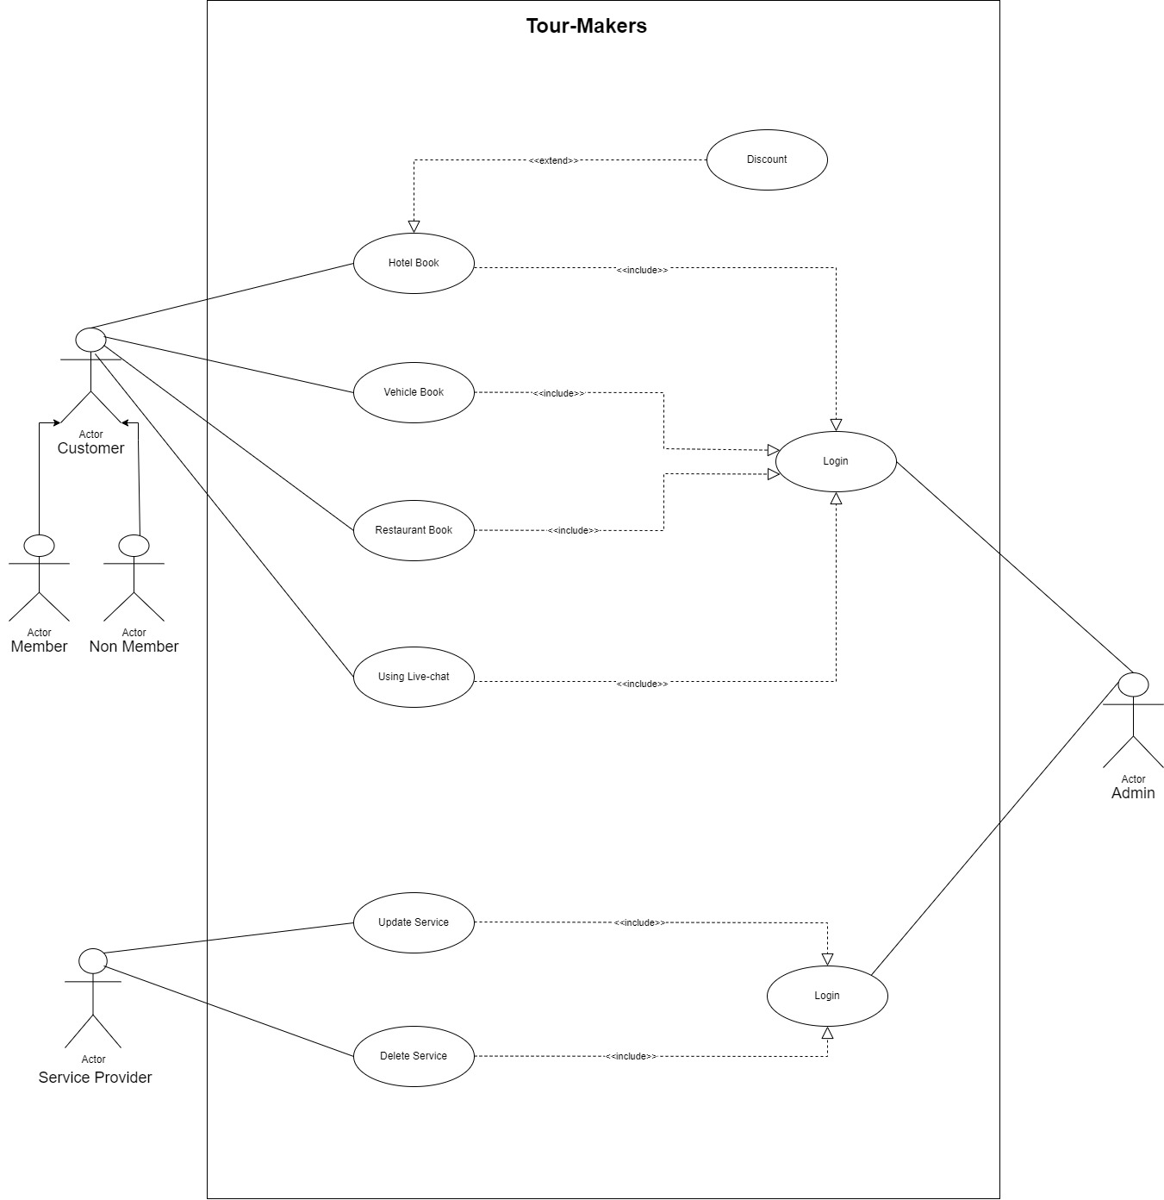

* **Normal And Alternative Scenario for Use-Cases**

## Use case Table 1:

|  |  |
| --- | --- |
| **User Case name**: Communicate with Tour Guides | Unique Id: CTG101 |
| **Area:** Tourist Dashboard | |
| **Actor(s):** Tourist, Tour Makers/Guides | |
| **Stakeholder(s):** Tourist (Customer), Tour Makers/Guides | |
| **Description:** Tourists can communicate directly with their assigned tour guides through the tour maker software to seek information, ask questions, and receive updates before and during the tour. | |
| **Triggering Event:** Tourist initiates a communication request with the assigned tour guide through the tour maker software's live messaging feature. | |
| **Trigger type:** External | |
| **Step Performed(Main Path)** | **Information For Steps** |
| 1. The tourist logs into the tour maker software. | UserID, Password |
| 2. In the tour details section, there is a dedicated "Communicate with Guide" option. | Customer dashboard |
| 3. The tourist clicks on the option to initiate communication. |  |
| 4. A messaging interface opens up, allowing the tourist to type their message and send it to the assigned tour guide. | All required information must be filled up |
| 5. The software confirms the successful delivery of the message to the guide. |  |

|  |  |
| --- | --- |
| 6. The guide, who is also using the tour maker software, receives a notification of the new message. | Get notified |
| 7. The guide views the message and responds with appropriate information or assistance. | Feedback |
| 8. The tourist receives the guide's response in the messaging interface. |  |
| **Alternative Scenario:**   * If the assigned guide is unavailable or does not respond within a reasonable time, the tour maker software can escalate the communication to the tour operator's customer support team. * In case of technical issues or network problems, the software may encounter difficulty in delivering the message to the tour maker. * There could be instances where the originally assigned guide becomes unavailable due to unforeseen circumstances. | |
| **Preconditions:**   * The tour maker software is accessible and functioning correctly. * The tourist has booked a tour and is registered/logged into the tour maker software. * The tour operator has assigned a tour guide to the tourist's booked tour. | |
| **Post-conditions:**   * The tourist's message is successfully sent to the assigned guide. * The tour guide receives the message through the tour maker software or a connected communication channel. * The conversation history between the tourist and the guide is logged and can be reviewed later if needed. | |
| **Assumptions:**   * Tourists are registered users of the tour maker software and have valid booking details. * Tour guides are assigned to specific tours and have access to the live-chat feature in the software. * The tour maker software has a secure messaging system to ensure privacy and data protection during communication. | |
| **Success Guarantee:** Tourists can easily and securely communicate with their assigned tour guides before and during the tour. The messages are delivered promptly, and both tourists and guides can receive and send messages without any technical hindrances. | |
| **Minimum Guarantee:** The tour maker software ensures that all communication sent by tourists reaches their assigned tour guides. At the minimum, tourists can send messages to their guides, even if the response time is not instantaneous. | |
| **Requirements Met:**  The communication feature in the software allows tourists to select the specific tour and guide they want to contact. | |

|  |
| --- |
| **Outstanding Issues:**   * While the software ensures basic communication between tourists and guides, it may lack advanced features like video calling, or translation support for international tourists. |
| **Priority:** High |
| **Risk:** Low |

**Use case Table 2:**

|  |  |
| --- | --- |
| **User Case name**: Tour Booking and Reservation | Unique Id: TBR102 |
| **Area:** Tourist Dashboard | |
| **Actor(s):** Tourist (Customer) | |
| **Stakeholder(s):** Tourist (Customer),Tour Makers | |
| **Description:** This use case describes the process of a tourist booking and reserving a tour in Bangladesh through the tour maker software | |
| **Triggering Event:** A tourist expresses interest in booking a tour through the software. | |
| **Trigger type:** External trigger (initiated by the tourist). | |
| **Step Performed(Main Path)** | **Information For Steps** |
| 1. The tourist opens the tour maker software or website and logs in with their account credentials. | UserID, Password |
| 2. The software presents a list of available tours with their descriptions, dates, prices, and available slots. | Tourist dashboard,Tour descriptions, dates, and prices. |
| 3. The tourist selects a preferred tour from the list. | Selected tour choice. |
| 4. The software displays the detailed itinerary, including the places to visit, activities, and duration | Desired tour date and time. |
| 5. The tourist checks the availability of slots for the chosen tour and selects the desired date and time. |  |

|  |
| --- |
| **Alternative Scenario:**   * Get Tour Updates and Reminders * Communicate with Tour Makers * Submit Feedback and Reviews * Book a Tour |
| **Preconditions:**   * The tour maker software is up and running. * The tourist has access to the tour maker software and is registered/logged in. |
| **Post-conditions:**   * The tourist's booking is confirmed, and the tour slot is reserved. * The tourist receives the booking confirmation with all relevant details. |
| **Assumptions:**   * The software is fully functional and accessible to tourists. * The account information provided by the account manager is accurate. |
| **Success Guarantee:** The success guarantee for the "Tour Booking and Reservation" scenario is that tourists can successfully browse available tours, select their preferred tour, check for available slots, and complete the booking process without any technical issues. |
| **Minimum Guarantee:**   * The minimum guarantee is that tourists can view the list of available tours and see basic information about each tour, even if they do not proceed with the booking. * The software should also inform tourists if a selected tour is fully booked or unavailable on the chosen date. |
| **Requirements Met:**  Tourists can view available tours and itineraries with detailed descriptions. |
| **Outstanding Issues:**   * Occasionally, the tour availability data might not be synchronized in real-time, leading to discrepancies between displayed availability and actual slots. * Payment processing might fail due to issues with the payment gateway or connectivity problems. * The software may lack support for multiple languages, limiting accessibility for non- English speaking tourists. * Some tourists may encounter difficulties in using the software due to an unfamiliar user interface. |
| **Priority:** High |
| **Risk:** High |

# Functional Requirements

The functional requirements of the Tour-Makers software include interactive map integration, multi-language support, live-chat, real-time location tracking, tour scheduling, user reviews, and a seamless payment system to provide a comprehensive and user-friendly platform for tourists.

The functional requirements of the system are:

### Tourist:

1. The software should allow tourists to create user accounts and profiles with essential information such as name, contact details, nationality, and language preferences.
2. Tourists should be able to search and filter destinations based on specific criteria, such as location, popularity, ratings, and available activities.
3. Tourists should be able to view reviews and ratings submitted by other users to make informed decisions about their travel plans.
4. The software should enable tourists to create personalized itineraries for their trips to Bangladesh. Tourists should be able to add multiple destinations, specify visit dates, and allocate time for each location.
5. The software should integrate with booking and reservation systems for hotels, transportation, and guided tours. Tourists should be able to make reservations directly through the application.
6. Tourists should be able to chat with the Tour-Maker staffs in a real time live conversation for their queries.

### Tour Makers/Guide :

1. The software should have a user authentication system where tour guides can create accounts and log in securely. Once logged in, they should be able to manage their profiles, including updating personal information, adding qualifications, certifications, and areas of expertise.
2. The software should allow tourists to browse through available tour guides, view their profiles, and book their services for specific dates and locations.
3. Tour makers should be able to create and manage their tour schedules through the software.
4. The software should facilitate real-time communication between tour guides and tourists.
5. Implementing a review and rating system is crucial for both tour makers and tourists. After each tour, tourists should be able to provide feedback and rate their experience.

### Hotel Manager:

1. The software should allow the Hotel Manager to create and manage their account with login credentials.
2. The Hotel Manager should be able to view and manage all hotel bookings, including upcoming, ongoing, and past reservations.
3. The software should provide a feature for the Hotel Manager to manage room inventory, including room types, availability, and rates.
4. The software should offer various reports and analytics to help the Hotel Manager monitor hotel performance and make data-driven decisions.
5. The software should enable seamless communication between the Hotel Manager and guests through various channels, such as email, chat, or in-app messaging.
6. The Hotel Manager should have access to a customer support module to handle guest inquiries, complaints, and requests efficiently.

# Non-Functional Requirements

Tour -Makers software's non-functional requirements include fast response times for seamless user experience, high security to protect sensitive user data, scalability to handle increased user demands, compatibility with various devices and platforms, user-friendly interface for easy navigation, and efficient resource utilization for optimal performance.

The non-functional requirements of the system are:

### Performance:

1. Identify the key performance metrics that are critical for the Tour-Makers software. These metrics will help measure the software's efficiency and responsiveness.
2. Set specific performance targets for each identified metric. These targets should align with the expectations of the users and the requirements of the application.
3. Perform thorough performance testing to evaluate whether the software meets the defined performance targets.

### Security:

1. All sensitive data, such as user credentials, personal information, and financial data, must be encrypted both in transit and at rest. This ensures that even if unauthorized parties gain access to the data, it remains unreadable and unusable without the proper decryption keys.
2. The software should have a robust authentication mechanism to verify the identity of users, guides, and administrators.
3. Incorporate comprehensive logging and auditing features in the software to monitor user activities, system events, and security-related incidents.
4. Logs should capture relevant information such as login attempts, access requests, data modifications, and any suspicious activities.

### Usability:

1. The tour maker software should have an intuitive and user-friendly interface that allows users to quickly understand and navigate through its features without the need for extensive training or guidance.
2. The tour maker software should respond quickly to user interactions, minimizing any noticeable delays or latency.
3. The software should be designed to cater to a diverse range of users, including those with disabilities or impairments.
4. The software should maintain proper colour contrast and avoid relying solely on color to convey information.

### Reliability:

1. This requirement defines the percentage of time the Tour-Makers software should be operational and accessible to users
2. The system should have a MTBF is a measure of how long the software can run between two consecutive failures.
3. The system should have a MTTR represents the average time it takes to restore the software's functionality after a failure occurs.
4. The system should have a system response time of no more than 1 second for routine operations.

* **Scalability:**

1. The system should be scalable in order to allow future business growth and development.
2. The system should be able to accommodate an increase in the number of users and data volume without noticeably degrading performance.
3. The system should be able to support new features and functions without requiring major changes to the present system.

### Maintainability:

1. To facilitate maintenance and upgrades, the system should be constructed using a modular architecture.
2. The codebase should be well-documented, and there should be explicit instructions on how to maintain and alter the system.
3. To ensure code maintainability and readability, the system should adhere to industry-standard coding techniques.